الطرق والممرّات التجارية العالمية (القائمة منها والمشاريع)
(سوريا وأهميتها الجيوسياسية)
Gobal Trade Routes and Corridors (Existing and Planned Projects)
(Syria and Its Geopolitical Importance)
By: Shervan Saif al-Din
introduction:
There is no doubt that roads are considered one of the most important connections between people, and they date back to the dawn of humanity. Especially with the development of human civilization and the necessity of communication among people, the relationship evolved to the point where goods and necessities are exchanged based on mutual benefit. Consequently, a road can be defined as: the means that allows a person to move and travel between regions, cities, and countries to fulfill their needs comfortably and efficiently. A road is essentially a clear path free from any obstacles that could hinder the traveler or the means of transportation used.
Thus, these roads achieve a connection between main cities and remote towns within a single country, fostering and recording commercial movement and economic prosperity. Moreover, roads facilitate the transport of agricultural crops from rural areas to cities and also ease the movement of the population from one settlement to another.
Through this research, we will try to focus on the most important sea and land routes ّ(only) that connect the world to each other, and make it a link between global cultures, in addition to being the most important sources of income for countries through their exploitation of the natural geography of these countries, and benefiting from it in transforming these roads and passages into a type of productivity that generates profits for governments and people together, and thus creating a type of economic prosperity for these countries, especially since the transportation sector is considered one of the most important productive sectors in bringing imports to the public treasuries of countries and governments. Therefore, we are trying to shed light on the most important of these sea passages and land routes that already exist, which tangibly affect current regional and international policies, and how some of these countries that control them control the joints of public policies. We are also trying to shed light on the projects that have already been put in place as future work plans, and the political and geographical conflicts over their actual implementation. Naturally, We will try - as much as possible - to focus on the collective status of information related to each project that is currently underway, such as the Suez Canal, or that is under planning, such as the Gulf of Al-Aqaba project or the so-called Ben Gurion Canal, or even some that are already underway, such as some parts of the Chinese Belt and Road project, which is considered an update of the ancient Silk Road... and so on.
Therefore, we can consider the Middle East and North Africa as one of the most important geographical regions that can control global roads and connections, as they basically control many waterways and airspaces in addition to the vast land area that can be invested in roads and railways. Therefore, we focus on this arena in particular and the projects that cross it. We also devoted the last part of our research to focusing on Syria in particular, due to its important role in shaping regional and international policies in our current situation, through the interest of most countries in its geography and the international and regional conflict over it for more than a decade directly.
We also try to focus on the geography of Kurdistan because of its geopolitical importance, especially with the occupying power clinging to it, as it is of great importance. Although it is not directly connected to the seas or oceans in the region to benefit from them as ports and marine docks, its land geography greatly helps in creating an atmosphere of important land connections, especially railway lines and highways.
-The study problem: defining each existing project, as well as defining projects that are currently being implemented or even those that are considered to be still in the concept stage, thus shedding light on these projects in terms of how they work in relation to existing projects, how they can be implemented in relation to projects or ideas, their chances of success or failure, determining their tactical and strategic objectives, highlighting the most prominent challenges they face, and their chances of success or failure.
-Importance of the study: It demonstrates the importance of international roads and corridors in determining the policies and positions of countries towards each other, and in forming local, regional, and international alliances in order to determine the global balance of power.
-Study objectives: To clarify and define the existing methods, projects and plans that countries are considering, to identify the short- and long-term political and economic goals of these future projects, to identify the challenges and obstacles they face at each stage, and to indicate the possibility of achieving them or not in light of the accelerating atmosphere of actual changes in global policies at all levels and the continuous change of alliances.
-Study Methodology: In our study, we followed the descriptive and analytical approach, by describing the most important aspects related to the economies of the countries that oversee the vital corridors, and the roads that pass through these countries, defining the political and economic reality surrounding them, and attempting to clarify the objectives sought to be achieved by each existing project or the one on plans, and the challenges it faces, and analyzing the data from all aspects and the possibility of its success or failure with regard to projects that are still only on paper.
O Suez Canal:
The Suez Canal is considered the most important man-made project linking the East and the West. Its importance lies in saving a lot of time and effort, as well as money and costs for transporting goods. Therefore, in addition to the tourist revenue to Egypt, it is considered one of the most important sources of foreign exchange income for Egypt. It also plays a significant role in shaping Egypt’s general policies and how it deals with others, by taking advantage of its geopolitical and strategic location. In addition, it makes Egypt one of the important pivotal countries in the Middle East and North Africa, thus playing a major role in shaping the region’s policies and the possibility of relying on it in this regard.
The Suez Canal is a waterway that connects the Red Sea and the Mediterranean Sea. It is located in Egypt, of course. It was opened in 1869 during the reign of the Egyptian Khedive Ismail Pasha, and it is considered one of the most important artificial straits to connect the continents of the world to each other, especially Southeast Asia and Europe. This saves time and money after ships and steamers travel longer distances by going around the African continent at the Cape of Good Hope. The canal passes through the Egyptian cities (Port Said, Ismailia, and Suez) with a length of 193.3 km, a width ranging from 52 meters to 205 meters, and a depth ranging from 8 meters to 40 meters. When the canal was opened, it was managed by the British and French for nearly a century before the canal was nationalized by the Egyptians in 1956. According to a study by Al Jazeera, “The economic impact and geographical location of the Suez Canal make it a strategic and global maritime passageway par excellence, as it shortens the maritime trade route between Europe and Asia without the need to take a longer route around the African continent.
Air: This naturally includes air navigation, which relies entirely on the transport of people and individuals due to its relatively high cost. It also transports goods and freight for light, expensive, or urgent transportation needs.
Maritime: This sector focuses primarily on the transport of goods in the commercial and economic sectors due to its low cost compared to the previous two sectors. It relies primarily on the transport of heavy industrial and military equipment, relying on the roads, waterways, and ports of coastal countries with access to major seas and oceans.

Consequently, this waterway accounts for the movement of about a third of the world’s ships, and thousands of giant commercial and military ships of various nationalities cross it annually, and 10% of international maritime trade passes through it.” The Suez Canal brings the East and the West closer together. It is a major source of income and injects significant momentum into the Egyptian economy. The economies of all countries that use the canal as a primary passage for their ships also benefit from it. Therefore, the Suez Canal is a major source of foreign currency entry into Egypt, as its revenues, for example, in the fiscal year 2022 - 2023, estimated at $9.4 billion, and it remained the third largest resource in terms of value, after remittances from Egyptians abroad and commodity exports in the early nineties of the last century. The canal continued to share with the Egyptian General Petroleum Corporation the lead in the highest surpluses achieved by economic entities, and it also pays the Egyptian state about 40% of its profits. For example, in the fiscal year 2020-2021, the Suez Canal Authority paid taxes worth 28.7 billion pounds, compared to 31 billion pounds in the previous fiscal year. The state also earned profits from it in the same year worth 47 billion pounds, compared to 44.8 billion pounds in the previous fiscal year’’.
O Ben Gurion Canal Project or the Israeli Canal:
proposed project for a waterway. It aims to link the Gulf of Al-Aqaba The Mediterranean Sea , which is not clearly defined in its implementation in the short and medium term, but it is a project already existing in Israeli plans that depend on the long-term strategic term , it is proposed that the canal be named after David Ben - Gurion ( The founding father of Israel and its first prime minister ) , presented the canal as a competitor to the Suez Canal. The Egyptian woman who went through many stages; Such as preventing Israel from sailing in it and in the Strait of Tiran, as happened in the years 1956, 1957, 1967, and 1973.
The Ben-Gurion Canal, if built, is expected to be 292.9 km (182 mi) long, nearly a third longer than the Suez Canal (193.3 km). The cost of constructing the Israeli canal is estimated at US$15–55 billion. The canal is proposed to run south to north, starting from the Gulf of Al-Aqaba, passing through the border city of ‘’Eilat’’, then to the Wadi Araba, a distance of 100 km between the Negev Mountains and the Jordanian highlands. It then turns west before reaching the Dead Sea and its basin, which is 430.5 meters below sea level. The canal then turns north again, heading to the Mediterranean Sea and avoiding the Gaza Strip. A proposed plan was prepared by the U.S. Department of Energy and Lawrence Livermore National Laboratory in July 1963. A secret document was published at the time, in which it was suggested that 520 nuclear bombs be buried and detonated to assist in the excavation process in the hills of the Negev Valley. These documents were declassified in 1993.
90 % done From Israeli trade with the world via the sea , therefore, the project of a canal linking the Red Sea and the Mediterranean Sea is considered of strategic importance to Israel , with the aim of controlling the most important shipping lines in the world, and also with the aim of creating a kind of competition with Egypt and the Suez Canal, and making Israeli ports of global importance and a pivot and link between Asia and Europe, in addition to building small tourist cities, summer resorts, cafeterias and hotels on this planned canal , with the aim of stimulating tourism alongside the economy. It is being studied to dig it so that it is 50 meters deep and 200 meters wide so that a ship 300 meters long and 110 meters wide can pass through it easily and comfortably , as such a ship is considered the largest in terms of size in the world at the present time, and the planned implementation period is five years, with the provision of 300,000 job opportunities for academics, engineers and ordinary workers ... etc.
Regarding the security of the canal, Israel is determined to place high-precision spy devices deep within the canal to detect prohibited weapons and materials. Israel also intends to involve three major American banks in financing, with an interest rate not exceeding 1 %, with the loan to be repaid over the next 30 years from the date of commencement of work. Therefore, it can be understood that the war that has been raging for more than a year in the Gaza Strip may serve, in one way or another, this old-new project that is important to Israel. The Palestinian lands will be somewhat open to the digging of the canal, without Israel having to compensate their owners in return when the lands are owned by Israelis. In addition, it will not allow more room for the Eastern camp, led by both China and Russia, and not leave the arena open to them.
O Belt and Road Initiative (Chinese Silk Roads):
China has been considered one of the most important countries in the world since ancient times, and it, along with India, is considered one of the most fertile countries in the world in terms of population growth, and thus its impact on human and economic development. Therefore, it is constantly working to secure and create the requirements of this rapid increase in massive human growth and to secure its needs and requirements. As for communication with the world, China is considered at the forefront in this field, and since it was known through its high-quality silk, its road also became known by this name (the Silk Road), which connects it with the Western world. Of course, it is not just one road, but rather several roads that connect to each other in the formation of a huge network of roads. Which in turn creates a kind of smoothness and does not create traffic and commercial congestion.
It can be considered The Belt and Road Initiative is a kind of modernization of the ancient Silk Roads, in addition to creating new roads and corridors that keep pace with the development taking place in the accelerating world, through land, sea and air routes, and focusing on a network of interconnected railways. China was at the top of the global economy until the beginning of the eighteenth century, and with the development of the West and the beginning of the industrial revolution there, the wheel of the Chinese economy began to decline at the expense of the West’s progress in this field, and the focus on the requirements and needs of global markets, especially development in the military and technological aspects. The decline of the Chinese economy was observed, especially after the end of World War II, and so on until 1978. The Belt and Road project was revealed for the first time by the Chinese President (Xi Jinping) in September of the year 2013, and in this framework, agreements were signed with more than 150 countries and more than 30 organizations. Internationally, it has mobilized nearly a trillion US dollars, and more than three thousand projects have been established with the goal of final completion of this project by the year 2049. Naturally, one of the most important goals of the project (according to Chinese officials when it was announced) was to build a large and unified market, and to benefit from global markets through cultural and economic exchange, and to enhance trust and understanding with other countries and the world, in addition to accelerating the arrival or delivery of its products to global markets. This project, of course, falls within the huge projects and investments from which 68 countries are likely to benefit directly or indirectly within the three neighboring continents, which are, of course, Asia, Europe, and Africa.
The project includes two main branches:
Maritime: (Maritime Silk Road) extends from the Chinese coast through Singapore and India towards the Mediterranean, Europe and the West.
Land: (Silk Road Economic Belt) includes 6 corridors:
1-The new Eurasian land bridge extending from western China to western Russia.
2-The "China-Mongolia-Russia" corridor extends from northern China to eastern Russia.
3-The "China-Central Asia-West Asia" corridor extending from western China to Turkey.
4-The China-Indochina Peninsula corridor extends from southern China to Singapore.
5-The China-Pakistan corridor extends from southwestern China to Pakistan.
6-The Bangladesh -China-India-Myanmar corridor extending from southern China to India.
Indeed, China has quickly begun to reap the benefits of this initiative; its exports increased by 16% and grew by 27% during 2017. It has also promoted its local currency (the yuan) globally, and has indeed entered the foreign exchange markets with full force. The Chinese yuan is considered the third strongest global currency and the most widely used reserve currency at the International Monetary Fund after the US dollar and the European euro, surpassing the Japanese yen and the British pound.
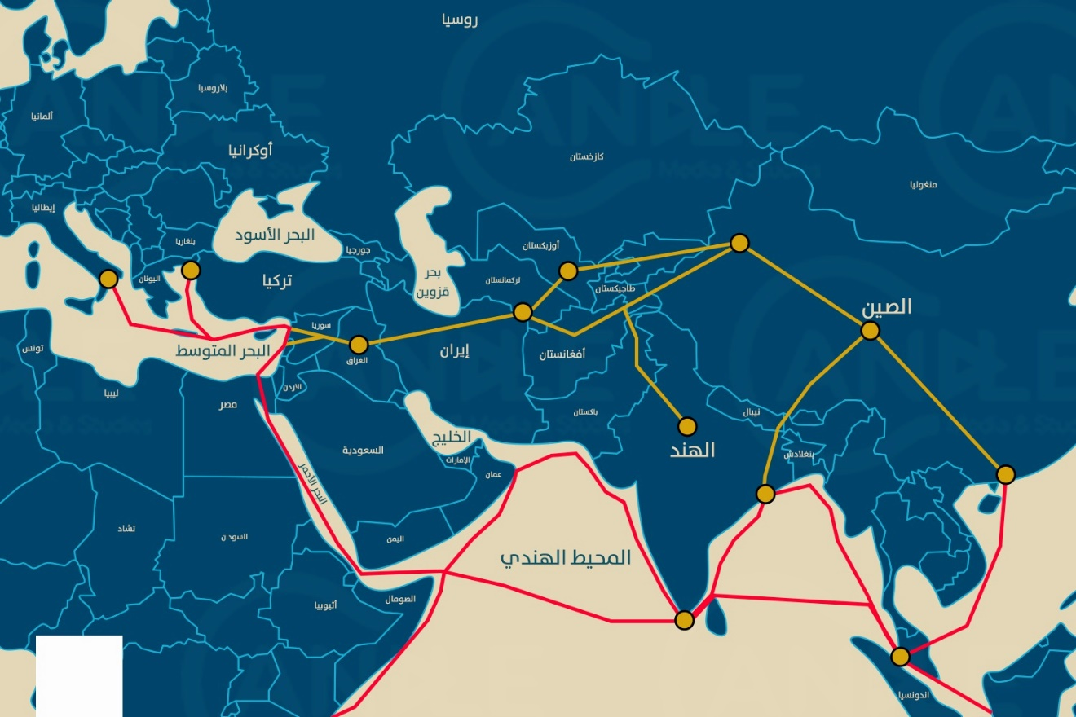
Of course, every project has international opposition and concerns, as well as difficulties and obstacles that limit or delay its implementation. This has been focused on the Belt and Road project in:
• Australia, India and Japan fear that China will dominate them, directly or indirectly.
• Western countries, especially Scandinavian ones, fear China's ambitions to dominate the global economy.
• Germany and France, the strongest economies within the European Union, they expressed their reservations about the initiative and the need to understand the Chinese strategy, and their refusal to accept the idea of dividing Europe between supporters and opponents of the initiative.
• The United States of America made clear its position on the initiative by opposing it completely and in detail, by proposing a completely opposite alternative under the name (the Free and Open Indo-Pacific Strategy), which includes or relies on three basic pillars: security, economy, and governance.
• It has also faced criticism that its primary objectives are to gain strategic power through participation in development and that it lacks proper financial oversight.
• Western governments have accused China of pursuing a new policy and a new type of colonialism, through debt-trap diplomacy, thus dominating the governments and leaders of those countries and forcing them into political dependence through it.
• The withdrawal of the United States from Afghanistan , which is considered a pivotal country within the initiative , is considered a severe blow to the Chinese project ; This is because it is considered the shortest route between Central and South Asia , and between China and the Middle East, especially after the Taliban took control of the two most important cities included in the project plan , namely the capital Kabul and Nangarhar. In addition, Afghanistan is considered one of the most important countries that possess natural resources such as lithium and copper, which are used in the infrastructure for electric cars. It also possesses a good stock of gold, iron ore, and precious stones. In recent years, Chinese influence has begun to increase in it, through the signing of memoranda of understanding between the two countries, during which China pledged to finance the country with approximately $ 100 million. Therefore, the United States of America may have felt the danger of this expansion by the Chinese dragon.
O Spice Route Project:
The Indian Spice Route is a trade route that connects the civilizations and continents of the ancient world from Southeast Asia through the Middle East, the Horn of Africa, and Europe. Since it focused on the spice trade of all kinds, and since India produces approximately 7.5 % of the global production of spices, it was given this name. Because India today ranks fifth in the world in terms of the strongest economies in the world and is neighboring to China and a strong competitor to it , especially after recording growth rates of 9% during the year 2022, it has become a target for Western countries , led by the United States of America , to create economic partnerships with it, and thus ; It is an old-new project, and its renewal or updating was announced on the sidelines of the 18th G20 Summit in New Delhi, India, in September 2023, with an approximate value of nearly 600 billion US dollars , starting from India, the United Arab Emirates , the Kingdom of Saudi Arabia, Jordan, Israel, and the European Union . A preliminary memorandum of understanding was signed between them on the sidelines of the meetings, and those in charge of this project emphasized that it differs from other similar corridors, as it is based on a participatory approach (the principle of partnership) rather than a centralized approach (the centralization of a specific country that enjoys the largest proportion of interests, gains, and returns in general). Naturally, the United States of America is considered the main supporter, sponsor, and driver of this project. As it is considered a cross-border company and an important part of the global foreign economic policy, the first beneficiary of these methods is it and its economic companies in the region. It is also concluded from this support that to confront Chinese influence in Asia and the Middle East and its project represented by the Belt and Road Initiative (Silk Road), and since Israel will become an important link between Asia and Europe within this project, it will impose it on the countries of the region through economic normalization as a first stage until political normalization is achieved over time.
It is clear from what has been published about this new project so far that it consists of three separate yet integrated corridors or paths:
1-first corridor: Eastern; aims to construct a maritime line starting from Indian ports and ending at the port of) Jebel Ali (in the United Arab Emirates.
2-second corridor: Southern; aims to construct a railway line extending from the UAE to the port of Haifa overlooking the Mediterranean Sea, crossing the territories of the Kingdom of Saudi Arabia, the Hashemite Kingdom of Jordan, and Israel.
3-third corridor: Northern; aims to build a maritime line linking Israel and European countries.
This project aims to establish railway lines and connect them to seaports, in order to support the process of trade exchange, the transfer of electricity, clean hydrogen, and the digital transfer of information through linking and digital transfer of data through fiber optic cables.
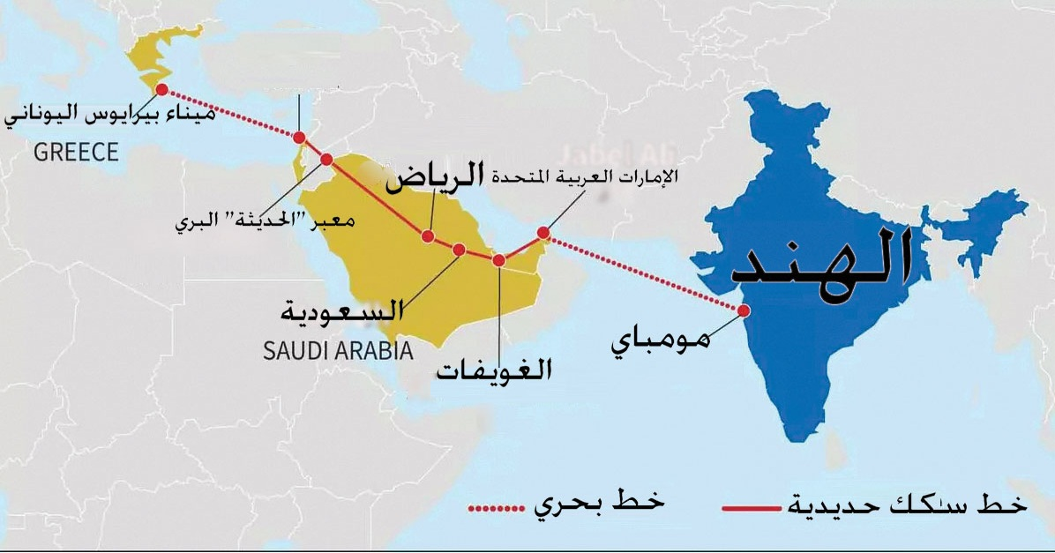

The objectives and economic gains expected from such a project:
1-Laying the foundations for a new phase in promoting international trade.
2-The growing influence of the economies of the participating parties in the global economy.
3-Maximizing economic gains and opportunities for all parties.
4-Strengthening the position of the Gulf countries on the global supply chain map.
5-Mitigating the impact of potential international emergencies on international trade.
6-cultural ties between countries along the corridor.
Of course, planning and implementing such a project is not without challenges and difficulties, which can be mentioned but not limited to:
1- The alternative projects (the Belt and Road Initiative) are aware of the extent of competition and development within themselves, and the acceleration of winning over controlling geographical powers such as Saudi Arabia and the Emirates
2-Countries that see this project as harmful, such as (Egypt), should be alerted. Or not benefiting directly or indirectly at least, such as Turkey and Iran, and the trend for the first is to accelerate the development line project, and the trend for the second is towards the railway line project.
3-The material cost factor and saving hundreds of billions of dollars for implementation.
4-The challenge of transporting, unloading and loading additional times, and moving between sea and land transport before the goods reach their final destination.
5-A security challenge, especially since the project passes through the tensest point in the world, which is the Middle East, and there are many calculations, alliances, and conflicting interests there.
O Development path:
The Grand Faw Port in Basra, southeast of Iraq, is the starting point for the “Development Road” project, which will connect Iraq to Europe via Turkey, through the provinces of Diwaniyah, Najaf, Karbala, Baghdad and Mosul. The port, which is being built by the South Korean company ‘’Daewoo’’ under an agreement worth approximately $ 5 billion, is located at the mouth of the Shatt al -Arab, where the Euphrates and Tigris rivers meet before flowing into the sea. It is expected to be the largest port in the Middle East upon completion. It will be built on an area of 54 square kilometers and has a capacity of 90 berths. The port’s “breakwater” has entered … The project, which is approximately 14,523 kilometers long, is listed in the Guinness Book of World Records as the longest breakwater in the world. The refinery's capacity is 300,000 barrels per day, and the second phase includes the construction of a petrochemical complex with a capacity of 3 million tons annually, and the construction of a power plant with a capacity of 2,000 megawatts. The project will also include the construction of one of the largest underwater tunnels, with a length of up to 2,444 meters, in addition to the establishment of an academy for refinery technology and the training of five thousand cadres who will manage it in the future.
The Iraqi government aims to launch the “Development Road” project to achieve several important points, including:
• Searching for an additional source of income for the Iraqi economy that would reduce its total dependence on oil, which Iraqi officials estimate at four billion US dollars annually if implemented and completed.
• Creating new job opportunities for the country’s available workforce (academic and regular), thus stimulating the private sector and reducing demand for government employment.
• Strengthening Iraq's geo -economic and political role by capitalizing on its geographical location as a link between the Gulf, Asia, and Europe.
The idea dates back to the 1980. The current core concept of the project is to connect the Grand Faw Port to a network of roads and railways extending northward across Iraq, reaching the Fishkhabur border point with the Turkish city of Mersin on the Mediterranean coast. This network would serve as a conduit for goods and merchandise traveling from Asia to Europe and vice versa. The total cost of the project is ُestimated at $17 billion, divided as follows: $3 billion for roads, $4 billion for railways, and $10 billion for various other aspects such as bridges, ports, and any additional developments. It is to be implemented in several phases, ending in 2050. According to Iraqi officials, the road will save approximately 15 days of shipping time between East Asia and Northern Europe. The highway, which will connect southern Iraq to the Iraqi-Turkish border, will be 1,190 km long, while the َplanned railway line will be 1,175 km long and will accommodate high-speed trains (300 km per hour for passengers and 160 km per hour for goods). These transport lines will pass through 12 Iraqi governorates stretching from south to north, which will contribute to enhancing trade and local integration. The Iraqi government estimates that the road will be able to transport 3.5 million containers loaded ُwith goods (equivalent to 22 million tons) annually by 2028. The capacity will gradually increase to reach 7.5 million containers by 2038. The railway is planned to be double-tracked, with each track accommodating 80-90 trains per day, most of which will be electric.
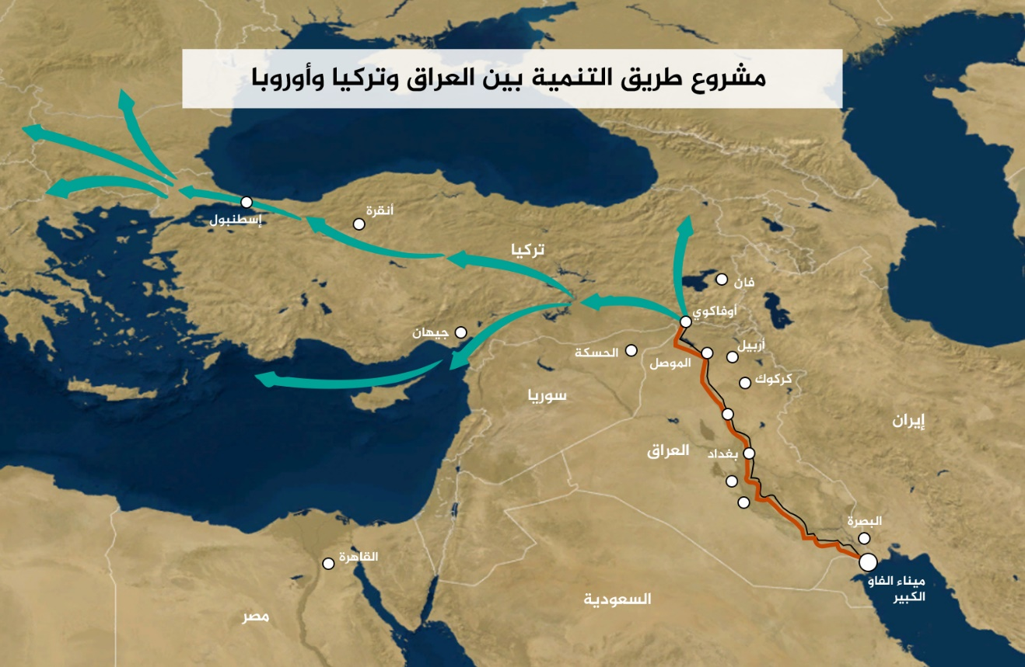

Of course, any economic project will face obstacles and challenges, and the most important challenges facing the path of development can be summarized as follows:
1-There are already existing paths and roads, Like the Egyptian Suez Canal, which most shipping companies in particular have adapted to, and the inability of the development path to compete with it basically, neither in terms of capacity nor even in terms of competitiveness in terms of material cost.
2-The limited view of Iraq's sea outlet to the Arabian Gulf, represented mainly by the port of Al-Faw.
3-The proposed project relies on multiple means of transport to include sea and land, and long land transport distances, with the possibility of increasing handling operations from one carrier to another, which will therefore lead to an increase in the cost of using this route.
4-The political and financial corruption that is rampant in Iraq raises doubts about the possibility of any project with a high cost being exploited for other private interests.
5-One of the project requirements is to establish high coordination relations with the Turkish neighbor, which is considered a major focal point, and thus.There are issues that are fundamentally related to it, such as the issue of water and the due quotas, and the security operations that Turkey is carrying out in northern and southern Kurdistan under the pretext of nationalism , as well as its economic cooperation with the Kurdistan Region and its bypassing of the central administration in Iraq.
6-The Iranian neighbor, who is not enthusiastic about this project has in his arsenal a railway project that connects the Khomeini port to the city of Khorramshahr inside Iran with the city of Shalamcheh in Basra, and from Iraqi territory it enters Syrian territory at the border city of Albukamal, reaching the city of Homs in central Syria and then the city of Latakia on the Mediterranean.
7-The Syrian neighbor also had his say, suggesting the possibility of utilizing Syrian lands instead of Turkish ones, and connecting Iraq to the Mediterranean and then the European continent.
8-Saudi Arabia, in turn, proposed the same idea in exchange for financial assistance and إthe project's connection to the Red Sea.
9- Kuwaiti apprehension about the Faw Port, which it sees as a strong competitor to the Mubarak Al-Kabeer Port in the Gulf region.
O Iranian Railway Project:
Iran is a pivotal state in the Middle East, and is currently considered a semi-nuclear state. It also sees itself as having an ancient civilization in the region that extends back thousands of years. Therefore, it has the right to control the region in a modern form of control, i.e. Economic capabilities, transportation routes, important links, imposing its identity on emerging countries, and striking at foreign Western interests, most notably hostility to Israel. All of the above became evident after the Islamic Revolution in 1978-1979, led by Ayat allah al-Khomeini. Among its strategic plans to control the Middle East is this important project, geographically and politically, which is represented by linking the Khomeini port in Iran with the Latakia port in Syria, passing, of course, through Iraqi territory, all of this via a modern railway connection back and forth. The Shalamcheh-Basra project is considered the nucleus of this project, despite the fact that the project is 32 km long and has an estimated cost of $120 million, borne equally by Iran and Iraq. However, its launch was actually announced in September 2023. Chine, from its side, even before the outbreak of the Arab Spring in the region, had signed agreements with Iran to strengthen economic ties. The two countries signed a railway agreement linking China and Iran, and subsequently the Middle East and Europe, in a revival of the Silk Roads. This will then evolve into the Belt and Road Initiative, with an initial project estimated to cost $2 billion.
As for the main project that is actually intended to be implemented, it is divided into:
1- The Iranian section: It starts from al-Khomeini Port on the Arabian Gulf and reaches the city of Khorramshahad, and from there to the Iranian border village of Shalamcheh, a distance of 17 km. This is the part of the project that was implemented until 2011. The railway line then extends 16 km towards the Iraqi border, reaching the Arvand River (Shatt al-Arab), the border between the two countries. Iran will build a bridge over the river to serve as the foundation for the railway line. Iran assumed responsibility for removing mines along a 16-kilometer length as part of the implementation of this project, and this task has been completed. Iraq is also responsible for removing mines along a distance of 16 to 18 km.
2- The Iraqi section: The starting point of the project is the Iranian-Iraqi border in the southeast of Iraq, for a distance of 16 km in Iraq, and then passing through a number of Iraqi cities, including Najaf, Karbala, Baghdad, and Al-Qaim, which borders Syria, with an approximate length exceeding 1000 km.
3- The Syrian section: extending from the Syrian city of Albukamal towards the coastal city of Latakia, and a line from Albukamal towards the Syrian city of Damascus, passing through the city of Homs, with a length of approximately more than 600 km. There is another route via the Al-Tanf border area, and Iran prefers the Albukamal route because its main goal is to reach the Mediterranean Sea, and also to avoid the Al-Tanf route where American bases are located.
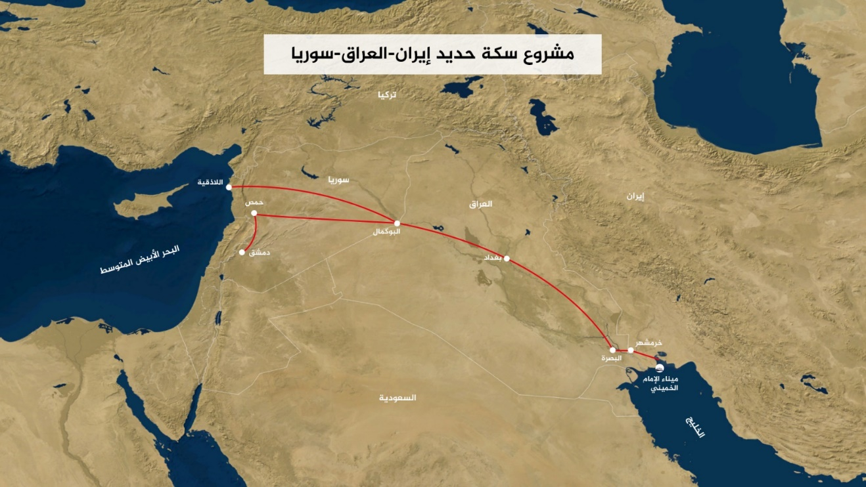

The project's primary and strategic objectives revolve around:
1. Making it a vital corridor and outlet for evading and circumventing US sanctions.
2. Iran is an ideological state and, according to its doctrine, believes in the holy sites in both Iraq and Syria. Therefore, the railway lines will provide a rapid communication network for visitors to the holy shrines, according to its beliefs. They will contribute to stimulating religious tourism in both Karbala, Iraq, and Damascus, Syria, thus preserving Shiite expansion and strengthening missionary missions.
3. These lines will serve as a legitimate corridor for smuggling and transporting weapons to Iran's proxies in both Iraq and Syria, and from there to Lebanon as well.
4. An attempt to control the Syrian coast and the waterways overlooking the Mediterranean, a form of competition with its Russian partner, which controls the port of Tartus, and thus the possibility of Iran controlling the port of Latakia.
As for the obstacles and hurdles facing the project, they can be summarized as follows:
1. Financing; Especially since Iran faces a stifling international economic blockade due to its nuclear program and unstable relations with the West, and the financial situation in both Iraq and Syria is no better.
2- Security factors and the state of instability in both Iraq and Syria.
3- International sanctions on entities and individuals in both Iran and Syria.
4- Larger international projects and strong competition with them.
5- The lack of transparency and clarity, especially on the Iranian side, in achieving other geopolitical goals.
O The North-South Corridor and the Zangezur Corridor:
The North-South Corridor is a network of roads and railways that allows Russian goods to reach the Indian Ocean and vice versa. The idea for the project primarily came from necessity following Western sanctions against Russia in particular. Some statistics indicate 12,000 sanctions against companies and individuals in Russia until the end of 2014 alone. In light of all these sanctions and international pressure, it was necessary to revive old road and port projects, as well as to create new ones. These sanctions and international harassment have also brought Russia closer and strengthened its relations with Iran, allowing them to benefit from each other geographically and politically. This project meets Russia's perennial need for access to warm waters. The project's deep roots date back to the last century. In the Russian Empire, the Caspian Sea-Persian Gulf route was developed in 1910, and was often used for freight delivery. The center of international North-South trade began in the 1930s in the form of a trans-Iranian railway. The project was initiated by Britain, with the goal of containing the influence of the Soviet Union in the Eastern Mediterranean region. An agreement was reached to establish a North-South transport corridor at the Second Eurasian International Transport Conference, held in Saint Petersburg in September 2000. A tripartite agreement was signed between Russia, Iran, and India, and ratified by all participants in May 2002. More than 10 countries subsequently joined the agreement. The study envisioned a 7,200-km transport corridor extending from the west coast of India to Saint. Petersburg, Russia, encompassing various modes of transport, primarily based on the following lines:
1- A sea corridor linking Indian ports, especially Mumbai, and the Iranian port of Bandar Abbas across the Arabian Sea.
2- Roads and railways across Iran linking the ports of Chabahar and Bandar Abbas to Tehran, and the Iranian border with Azerbaijan.
3- Railway networks along the Caspian Sea coast linking Iran and Azerbaijan via the Iranian cities of Rasht and Astra in Azerbaijan.
4- Railway and road networks linking Astra and Baku (the capital of Azerbaijan) and from there to Russian territory, starting with the city of Makhachkala (a Castle in southern Russia), then the Volga and Grad Saratov, Moscow, and Saint Petersburg.
5- Connections from Moscow and Saint Petersburg to the European cities of Helsinki, Tallinn, Riga, Vilnius, and Minsk.
This means, they connect Indian ports on the Arabian Sea in the south to major Russian cities, passing through Moscow in the north, reaching the northeastern European capitals of Finland, Latvia, Estonia, and Belarus.

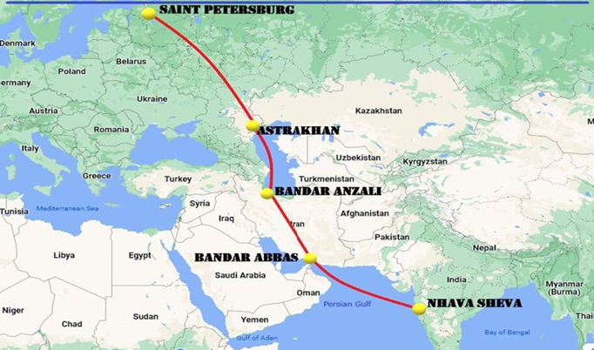

The most significant obstacles facing the project are:
1-The massive amount of funding required, given the international sanctions and economic blockade the sponsoring countries are suffering from. This fundamentally impacts the ability to provide the liquidity needed for such a massive project, given the already dilapidated infrastructure.
2- Competition with existing waterways, such as the Suez Canal and the Northern Sea Route, and the potential for actual competition in terms of duration and cost.
3- Political disputes between neighboring countries and political blocs; for example, there is the Pakistani-Azerbaijani-Turkish bloc versus the Indian-Iranian-Armenian bloc.
The Zangezur Corridor, a 40-kilometer-long land strip that runs through the Armenian Zangezur region, connects Azerbaijan to the Nakhchivan Autonomous Region, which is administratively part of Azerbaijan but geographically separate from it. Azerbaijan views the opening of this crossing as a way to restore direct communication between its territories, promote economic and social development, and contribute to strengthening economic development with its strategic partner in the region, meanwhile, Turkey views the corridor as a shortcut to its strategic partner, enhancing Turkey's position in the transport of goods to and from Europe and Central Asia. Russia, for its part, views the corridor as strengthening its position in the region and creating an alternative to the European and Western blockade. It also views it as an alternative to the Georgian corridor, which has faltered from time to time. Armenia would also benefit from opening this corridor to end its isolation from its Turkish and Azerbaijani neighbors. It would be a suitable alternative to the Georgian pipeline, which has faltered due to the faltering Russian-Georgian relations. However, it fears the inability to directly control the corridor and the lack of any direct sovereignty or control over it. This would impede its ability to safeguard its national interests, and consequently, it fears popular discontent. Iran, of course, fears a geographic separation from Armenia, which would lead to its being besieged by its Turkish and Azerbaijani allies, thus posing a direct threat to Iranian national security. Furthermore, the corridor aims to transport energy from Eurasia and Central Asia to Europe, which would ultimately end Europe's need for Iranian energy. It is also viewed as a NATO project, given that Turkey is a member, providing access to the Caspian Sea and from there to Russia.
O Existing Roads and Future Projects in Syria:
As previously mentioned, the Middle East is a nexus and a hub connecting the three continents of the world (Europe, Asia, and Africa). Geographically, Syria is considered one of the most important parts of this geography. Accordingly, it has always been the primary focus of all geopolitical and economic projects planned for this region, due to its strategic and geopolitical location. Naturally, foreign trade is a fundamental pillar of the Syrian economy, through the sale of local products, thus securing foreign exchange to support economic plans and development, and also to secure industrial materials used in the production and consumption processes. As for the most important land routes, we can limit them to three main roads around which the focus is centered: the M42, M4, and M5.
1- The International Highway or Silk Road (M42):
This is one of the most important roads, as it is considered part of the Chinese Belt and Road Project. It connects the port of Latakia to the Iraqi border. The road is strategically and economically important for Syria, Iran, Iraq, and China. The Silk Road, in its section that passes through Syria, Iraq, and Iran, can help enhance security cooperation between these countries. It can be used to quickly and easily transport troops and military equipment, as well as goods and products. This means that the road will play a role in connecting the Iranian axis, strengthening Iranian military power, and strengthening Chinese economic influence. This could create a china-Iranian alliance if Iran becomes a gateway for Chinese expansion towards the Mediterranean.
2- The M4 International Highway:
It extends from the border with Iraq to the city of Latakia on the Mediterranean coast. The road begins at the Al-Yarubiyah crossing on the border with Iraq in Al-Hasakah Governorate, then heads west to the south of the city of Qamishli. The road continues west towards the north of the city of Raqqa and passes through the city of Ayn Issa. The road runs parallel to the Turkish border and passes through the cities of Sarrin and Kobani (Ayn al-Arab). The road crosses the Euphrates River at the Qara Qozak Bridge and heads towards the city of Manbij. The road then heads south through Deir Qaq and enters the city of Aleppo from the northeast. It continues south of Aleppo, passing through the industrial areas of Sheikh Najjar. The M4 highway joins the M55 highway at the city of Saraqib, east of Idlib Governorate. It then separates from the M5 highway and heads west to reach the city of Ariha in Jabal al-Akrad (Al-Zawiya) Mountains. It then heads towards the town of Muhambal in the Al-Ghab Plain, passing south of the city of Jisr al-Akrad. Al-Shughour, and heads south to the city of Latakia on the Syrian coast overlooking the Mediterranean Sea.
The strategic importance of this road stems from the fact that it is a strategic link and connection between the most important regions in Syria. It is the northern and northeastern region and the western and northwestern region. It is also considered a vital artery for trade and the economy in Syria, as it connects the most important industrial and commercial areas in the Syrian interior, such as Aleppo, Hama, Homs and the coast, with the areas containing raw materials for agricultural and animal products in the northeastern and eastern regions of Syria. Therefore, this road is considered the main supply line for goods and products between these regions. It connects Syria’s sea gateway to the Mediterranean Sea with the Syrian interior. It is noteworthy that this road was almost cut off in some parts after the Turkish military operation in October 2019 in both the cities of Serekaniye (Ras al-Ayn) and Gire Spi (Tal Abyad). Therefore, the existing autonomous administration had to work to create an emergency alternative, which was actually done by linking the city of Hasakah to the city of Raqqa and then to the city of Manbij, which has become the largest commercial gathering, especially after the city of Aleppo became almost marginalized and not interacting as it was intended to be, especially with the Turkish pressure to open the Abu al-Zandin crossing with the Syrian side. To strangle the entire eastern region, put pressure on the autonomous administration there, and create a state of economic strangulation.
3- The International Highway (M5):
This road is 450 kilometers long and extends from the Nassib crossing on the border with Jordan to the Bab al-Salam crossing on the border with Turkey, via major cities such as Daraa, Damascus, Homs, and Hama. From there, it continues to Aleppo, heading towards the Death Roundabout, and then towards the Turkish border. It is known there as the Aleppo-Gaziantep International Highway. North of Homs, it intersects with the international highway connecting Homs to the Syrian coast and its cities of Tartus, then Baniyas, then Jableh, all the way to Latakia. In the capital, Damascus, it also intersects with the international highway connecting neighboring Lebanon.
The strategic importance of this road lies in its connection to the four largest cities in Syria: Damascus (the political capital), Homs, Hama, and Aleppo (the economic capital). It also passes through Idlib Governorate to the north and Daraa Governorate to the south. This inland region is considered the most important strategic area in Syria in terms of population density. Internationally, this route is considered a land trade corridor between Europe and the Arabian Gulf, passing through Turkey and Jordan. However, the road remains closed after the recent events that erupted in Syria in 2011. It was an important economic artery for Syria, transporting goods and products between different parts of the country for internal trade, and also for foreign trade, connecting Syria to neighboring countries. It connected Syria to Turkey via two border crossings: the Bab al-Hawa crossing (north of Idlib) and the Bab al-Salam crossing, and to the south, it connected Syria to Jordan via the Nassib crossing in Daraa. Before the recent crisis, the value of transporting goods was estimated at $25 million per day, thus helping to boost the Syrian economy and provide many job opportunities.
Due to Syria's aforementioned geostrategic location and these important land routes, it has become a prime target for regional and international projects, and how to leverage them and exploit the circumstances to achieve their goals and implement their projects on the ground. These projects include:
1- The Arab Gas Pipeline:
It includes Egypt, Jordan, and Syria. The pipeline project began within the framework of bilateral dialogue between Egypt and Jordan in 2001. A memorandum of understanding later included Syria and Lebanon. Israel, Turkey, and Iraq also signed cooperation agreements on the transregional pipeline project. As planned, the pipeline was supposed to have economic importance, not only for the Arab region, but also for Europe, Asia, and Africa. It was planned to extend to the Syrian-Turkish border and join the gas pipeline network in Turkey. The natural gas pipeline would then be connected to the Nabucco pipeline. Thus, The 1,200-kilometer-long Arab Gas Pipeline Transports Egyptian gas to Jordan, Lebanon, Syria, and Israel. The first section of the natural gas field, which extends 265 kilometers from the El Arish natural gas field in Egypt to Aqaba in Jordan, was completed in 2003 at a cost of $200 million. The 36-inch diameter pipeline has a capacity of 10.3 billion cubic meters of natural gas annually. The second section, which is 390 kilometers long, extends from the port of Al-Aqaba through Amman to Al-Rehab (30 km from the Jordanian-Syrian border). It was put into operation in 2005, and the cost of the second phase was approximately $300 million. The line from Al-Rehab to Homs, which passes through Daraa and Damascus, was completed in 2008. This section is 330 kilometers long. In 2009, the pipeline was extended from Homs to Baniyas in Syria. In Tripoli, Lebanon, the United States and the Western bloc support this project because it represents competition with the Eastern bloc and a form of indirect normalization with its ally, Israel. Consequently, the Eastern bloc, represented by Russia and Iran, opposes this project because of its direct impact on their economic and geopolitical interests.
2- The Qatari-Turkish Gas Pipeline:
This is a Qatari proposal to build a $10 billion, 1,500-kilometer natural gas pipeline across Saudi Arabia, Jordan, and Syria. From Syria, the pipeline would branch into three branches: one to Tripoli, Lebanon, one to Latakia, Syria, and the third to Turkey. The goal of the pipeline was to connect Qatar directly to European energy markets, which would give Qatar decisive dominance over global natural gas markets and enhance Qatar's regional power. In 2009, Syria refused to allow the pipeline to pass through it, leading to the failure of the project. The reasons for the refusal were related to the nature of Syrian-Iranian relations and their direct impact, as well as the fear that it would lead to strengthening Saudi power over Syria, and to maintain relations with Russia and block Gulf competition in European markets with Russian gas. Consequently, the failure of the Qatari pipeline crossing Syria was a blow to the United States and the European Union, as it could have strengthened Europe's energy security and limited Russia's power in the region. It was also a loss for Qatar, which had hoped the pipeline would become an additional source of income. Therefore, it can be understood from the above that the Western camp supported the project, while the Eastern camp, led by Russia and Iran, opposed it.
3- The Iranian Gas Pipeline:
The Iranian Islamic Pipeline extends from the Iranian side of the Iranian gas field in the Arabian Gulf, passing through Iraq via Syria, and then branches into three branches: from Homs, extending to Latakia, Turkey, and the ports of Lebanon. The primary objective of this project is to serve as an alternative to the Qatari project. It also aims to pump Iranian gas to Europe, strengthen Iran's geostrategic and economic position, and circumvent Western sanctions. Naturally, this is where the balance between beneficiaries and victim’s reverses. Iran, its proxies, and its allies are the direct beneficiaries, as opposed to the opposition of the Western camp, led by Israel.
4- Kirkuk-Banias Gas Pipeline:
This pipeline is considered, to some extent, an old-new project, as it originally began with the development of the regional energy transportation system in the Middle East in 1952. Construction of a crude oil pipeline from the Kirkuk oil field in Iraq to the Syrian port of Baniyas was completed. The pipeline is approximately 1,000 kilometers long About 800 kilometers long and with a capacity of 300,000 barrels per day, the Syrian army destroyed the pipeline in response to the British and French control of the Suez Canal in 1956, but it was later rebuilt in 1972. Due to the subsequent difficult negotiations regarding increased customs tariffs for transporting Iraqi oil through the Syrian part of the pipeline, Iraq decided to build a new pipeline bypassing Syria. Indeed, in 1975, the pipeline linking Kirkuk to the Arabian Peninsula was built, which was destroyed following the US invasion of Iraq in 2003. Negotiations are still ongoing with the Syrian and Saudi sides regarding the possibility of restarting one of the two lines without reaching any results for its purpose, although everyone benefits from such a project in contrast to the absence of anyone directly harmed or opposed to it, with the exception of Iran, which is sensitive to the possibility of it being a competitor to its own project.
Conclusion:
Based on all the above existing roads, corridors, and projects under study, it becomes clear that most of the political problems that surface as a façade actually carry within them, or lie behind, purely economic interests. For example, the Suez Canal, which was nationalized in 1956, is considered one of the most important corridors linking East and West and vice versa. Although Egypt relies primarily on it for the country's foreign exchange income, it has still fallen short of its potential for developing Egypt and its civil society. Therefore, with the rapid and enormous increase in the global population in general, it has become an urgent necessity to find industrial corridors and alternative roads to speed up the process of access and delivery. Consequently, the old-new Ben-Gurion Canal project is a project in itself as both a parallel and an alternative to the Egyptian Suez Canal. Opening roads and passages creates new job opportunities with the massive global population increase, as previously mentioned. It also creates a new type of trade and economic relations with neighboring countries, and a kind of indirect normalization between countries that have tensions with each other, such as Israel and the Arab countries, or such as Azerbaijan and Armenia, or Russia and Georgia, etc. Many of these projects create a kind of chaos if they fundamentally carry expansionist projects and ideological backgrounds in their seeds; such as the Iranian railway project, which is no secret to anyone that it is considered an outlet to get rid of Western sanctions in parallel with direct communication with its arms in the region, in addition to Shiite expansion, another example of a development path whose founders are trying to avoid passing through Kurdish lands as much as possible, especially the southern Kurdistan region. In order not to benefit from it directly, and to try to create a kind of aura of fear from the Kurdish liberation movement in northern Kurdistan that it constitutes a kind of threat to any kind of development in the region, and to stain its name with hostility to any kind of community development. In Syria, too, its situation is like the rest of the existing geographical countries; with the outbreak of the Arab Spring revolutions in North Africa and the Middle East, the Syrian street participated with the pure intention of bringing about positive change in the country; however, the regional and international power had another opinion on the matter and tried, as much as possible, to benefit from it. For example, the Qatari media tried as much as possible to get rid of the Baath regime, as a reaction to the latter’s refusal to accept the Arab project that was planned to transport Gulf gas through Syrian territory to Europe. In return, the Russians intervened to prevent this in order to thwart this project in one word; Because it primarily harms Russia's supreme interests and national security, as well as its gas supplies to Europe, which it considers a significant pressure card, especially after the recent Ukrainian war, which has exhausted Russia's military, political, economic, and diplomatic power. The competition between the world's major economies, which sometimes reaches the point of hidden conflicts, is nothing more than a struggle over economic interests, routes, and corridors for the optimal and fastest distribution of their goods and commodities, and a process of political, economic, and geographical control.
References and Sources:
- Amal Al-Kafri - Dr. Hassan Abdel Haq, "Trade and Its Importance in Northern Mesopotamia between 1900 and 612 BC," Journal of Historical Studies, Volume 38, Issue 146, 2022.
- Muhammad Khamis Al-Zaruka, "Geography of Transport," Dar Al-Nahda Al-Arabiya, Beirut, 1986.
- Fouad Mohammed Al-Saqqar, Geography of International Trade, Al-Maaref Establishment, Alexandria, 1997.
- Raad Hassan Al-Sarn, Fundamentals of Contemporary International Trade, Dar Al-Rida Publishing House, Damascus, 2000.
- Dr. Abdul Raouf Al-Rahban, The Economic Importance of Syrian Foreign Trade and the Factors Influencing It, Damascus University Journal, Volume 29, Issues (3 and 4), 2013.
- The Belt and Road Initiative: What Does It Hold for the Arab Region? A working paper submitted to the United Nations Economic and Social Commission for Western Asia (ESCWA) Sixth Special Session, Amman, December 21-22, 2019.
- Abdullah Ocalan, On the Economy, Abdullah Ocalan's Views on the Economy, Publications of the Abdullah Ocalan Academy for Social Sciences.
Abdullah Ocalan, Manifesto of Democratic Civilization, Volume 5, The Kurdish Question and the Solution of the Democratic Nation, in Defense of the Kurds Trapped in the Jaws of Cultural Genocide, translated by Zakho Shiar, Azadi Press, April 2014.

Transportation can be divided into: Land transportation: This includes all types of cars and trucks, and relies primarily on a road network and land transportation nodes. It is used effectively for short distances, primarily within a single country. It also includes railways, which are relied upon to transport both people and goods.
The Suez Canal is the longest waterway in the world, January 14, 2024 AD, Al Jazeera Encyclopedia https://www.aljazeera.net/encyclopedia/2024/1/14/%D9%82%D9%86%D8%A7%D8%A9%D8%A7%D9%84%D8%B3%D9%88%D9%8A%D8%B3-%D8%A3%D8%B7%D9%88%D9%84-%D9%85%D9%85%D8%B1-%D9%85%D8%A7%D8%A6%D9%8A-%D9%81%D9%8A-%D8%A7%D9%84%D8%B9%D8%A7%D9%84%D9%85
Ben-Gurion Canal Project, Wikipedia https://ar.wikipedia.org/wiki/%D9%85%D8%B4%D8%B1%D9%88%D8%B9_%D9%82%D9%86%D8%A7%D8%A9_%D8%A8%D9%86_%D8%BA%D9%88%D8%B1%D9%8A%D9%88%D9%86#:~:text=%D8%AA%D9%8F%D9%82%D8%AF%D9%85%20%D8%A7%D9%84%D9%82%D9%86%D8%A7%D8%A9%20%D8%B9%D9%84%D9%89%20%D8%A3%D9%86%D9%87%D8%A7%20%D9%85%D9%86%D8%A7%D9%81%D8%B3,%D9%81%D9%8A%20%D8%A7%D9%84%D8%B3%D9%86%D8%A9%20%D8%A7%D9%84%D9%85%D8%A7%D9%84%D9%8A%D8%A9%202022%2F2023.
Belt and Road: How America placed the fate of China's most important project in the hands of the Taliban, August 17, 2021, Al Jazeera Encyclopedia https://www.aljazeera.net/encyclopedia/2021/8/17/%D8%A7%D9%84%D8%AD%D8%B2%D8%A7%D9%85%D9%88%D8%A7%D9%84%D8%B7%D8%B1%D9%8A%D9%82-%D9%83%D9%8A%D9%81-%D9%88%D8%B6%D8%B9%D8%AA-%D8%A3%D9%85%D9%8A%D8%B1%D9%83%D8%A7-%D9%85%D8%B5%D9%8A%D8%B1
Special withdrawal units consist of five currencies: • US Dollar (USD) at 41.73%. • Euro (EUR) at 30.39%. • Yuan (RMB) at 10.98%. • Japanese Yen (JPY) at 8.33%. • British Pound (GBP) at 8.09%.
Notes about the India-Gulf-Europe Corridor Project, Dr. Hassan Nafaa, September 28, 2023, Arab Renaissance Center for Democracy and Development. https://ardd-jo.org/%D8%A7%D9%84%D9%85%D8%AF%D9%88%D9%86%D8%A7%D8%AA/%D9%85%D9%84%D8%A7%D8%AD%D8%B8%D8%A7%D8%AA-%D8%AD%D9%88%D9%84-%D9%85%D8%B4%D8%B1%D9%88%D8%B9-%D8%A7%D9%84%D9%85%D9%85%D8%B1-%D8%A7%D9%84%D9%87%D9%86%D8%AF%D9%8A-%D8%A7%D9%84%D8%AE%D9%84%D9%8A%D8%AC/
The India-Middle East-Europe Global Trade Corridor: Opportunities and Challenges, October 5, 2023, International Institute for Iranian Studies. https://rasanah-iiis.org/%D8%A7%D9%84%D9%85%D9%85%D8%B1-%D8%A7%D9%84%D8%AA%D8%AC%D8%A7%D8%B1%D9%8A-%D8%A7%D9%84%D8%B9%D8%A7%D9%84%D9%85%D9%8A-%D8%A7%D9%84%D9%87%D9%86%D8%AF%D9%8A-%D8%A7%D9%84%D8%B4%D8%B1%D9%82-%D8%A3%D9%88/
The Geopolitical and Economic Dimensions of the Development Road Project and its Chances of Success, June 8, 2023, Al Marsad Analytical Magazine, Emirates Policy Center. https://marsaddaily.com/Article_Detail.aspx?authorid=93&Articleid=572
The Iran-Syria Railway Project: Opportunities, Challenges, Objectives, and Implications, Muhammad Ghazaleh, March 14, 2024, Candle Center for Studies. https://candlegrup.com/%D9%85%D8%B4%D8%B1%D9%88%D8%B9-%D8%AE%D8%B7-%D8%A7%D9%84%D8%B3%D9%83%D8%A9-%D8%A7%D9%84%D8%AD%D8%AF%D9%8A%D8%AF%D9%8A-%D9%85%D9%86-%D8%A5%D9%8A%D8%B1%D8%A7%D9%86-%D8%A5%D9%84%D9%89-%D8%B3%D9%88%D8%B1/#_ftn9
An alternative route to a new North-South world linking China, Russia, India, and Iran, December 18, 2023, Qasioun newspaper of the Popular Will Party. https://kassioun.org/economic/item/79204-2023-12-18-05-08-01
Trade routes in Syria and their impact on the conflict equation and paths to resolution, December 26, 2023, Candle Center for Studies. https://candlegrup.com/%D8%A7%D9%84%D8%B7%D8%B1%D9%82-%D8%A7%D9%84%D8%AA%D8%AC%D8%A7%D8%B1%D9%8A%D8%A9-%D9%81%D9%8A-%D8%B3%D9%88%D8%B1%D9%8A%D8%A9/
Trans-Syrian Power Line Projects: Intertwined Interests, December 2, 2023, Candle Center for Studies. https://candlegrup.com/%D9%85%D8%B4%D8%A7%D8%B1%D9%8A%D8%B9-%D8%AE%D8%B7%D9%88%D8%B7-%D8%A7%D9%84%D8%B7%D8%A7%D9%82%D8%A9-%D8%A7%D9%84%D8%B9%D8%A7%D8%A8%D8%B1%D8%A9-%D9%85%D9%86-%D8%B3%D9%88%D8%B1%D9%8A%D8%A9-%D8%AA%D8%B4/

